Module Name: Automation testing
Test Case ID: 10
Webpage URL: https://www.saucedemo.com/

Scenario ID: 1
Steps:
1. Enter valid username
2. Enter valid password

Screenshots:
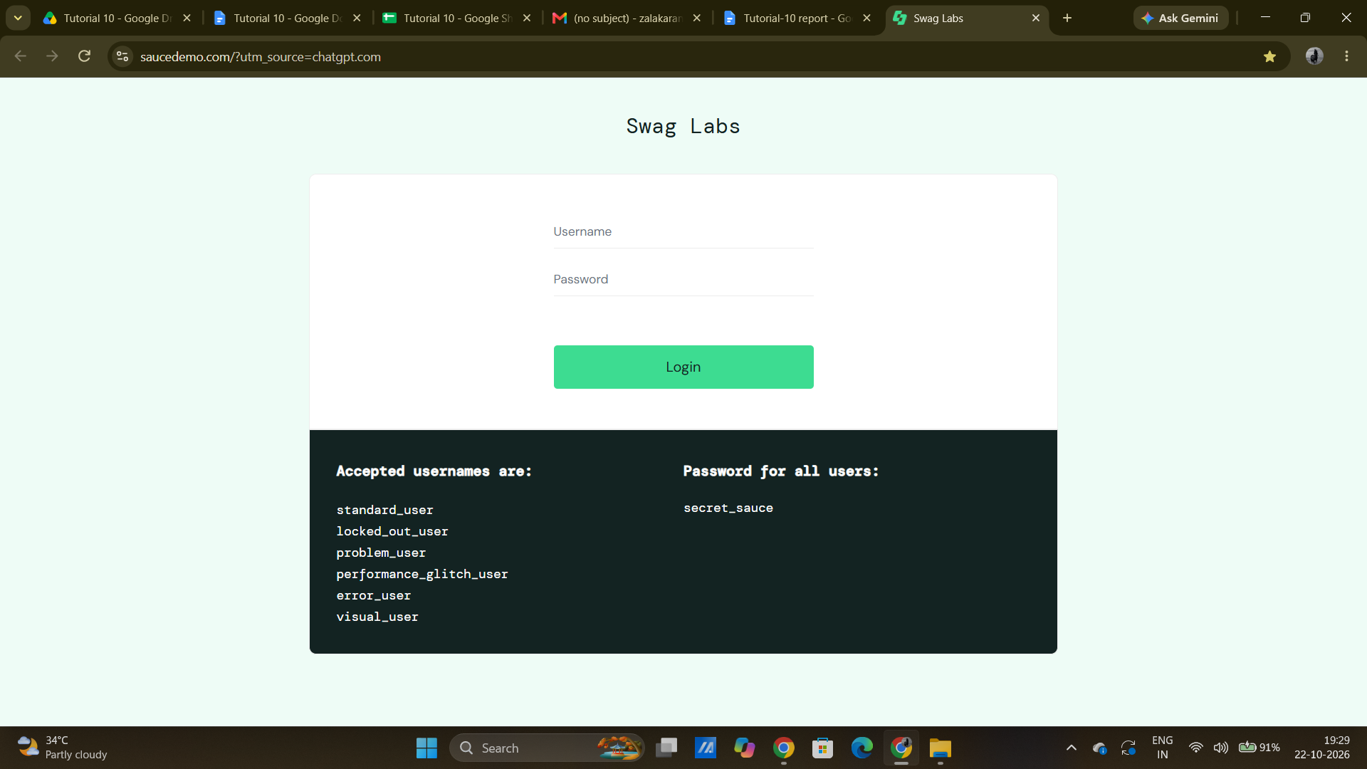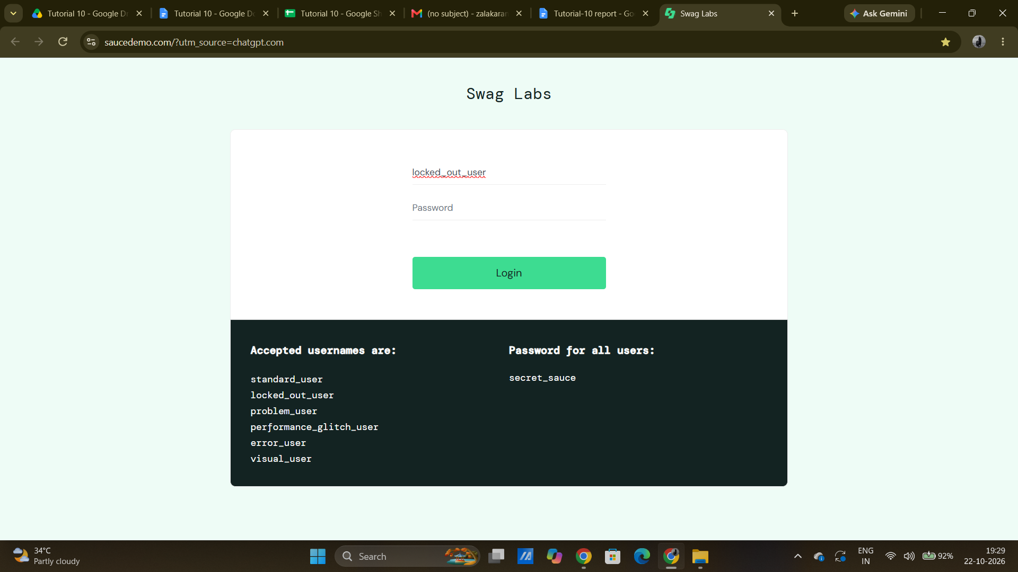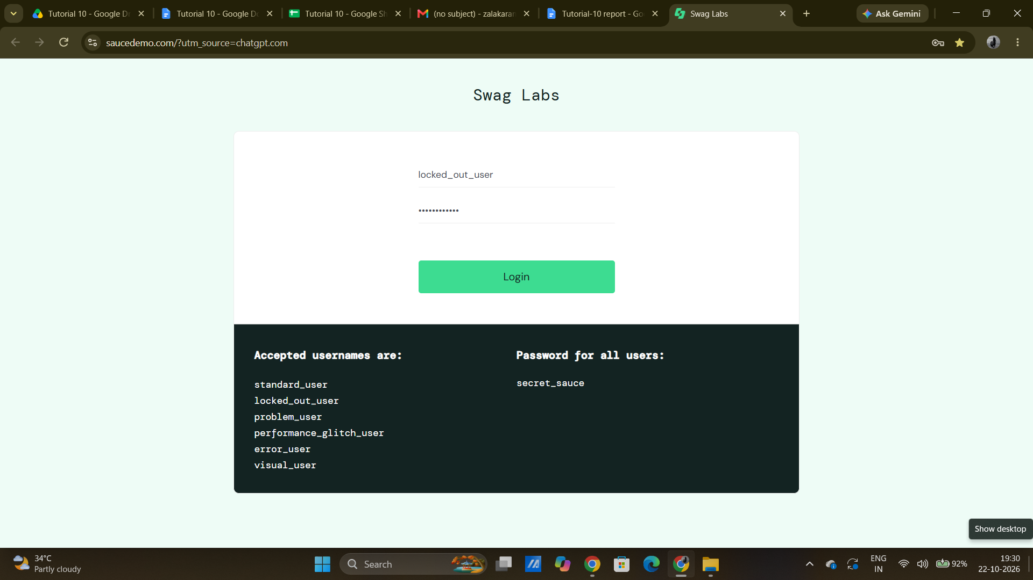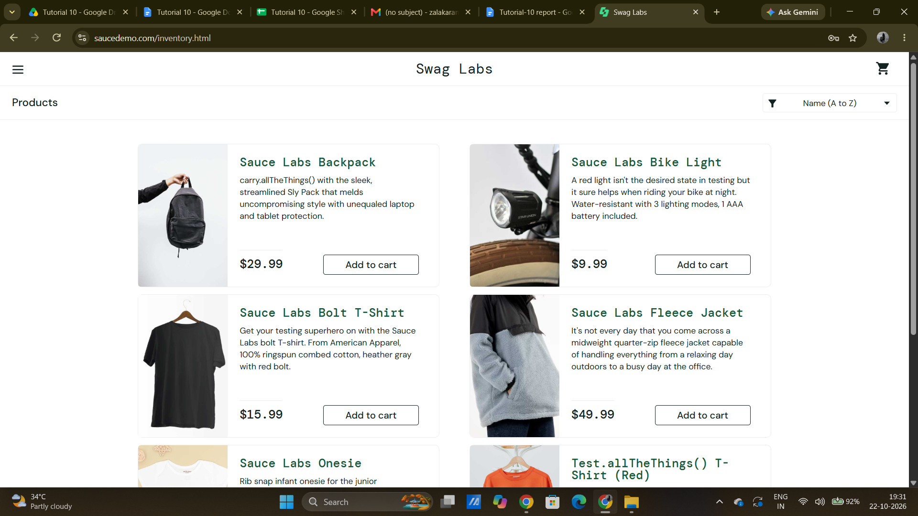Scenario ID: 2
Scenario: invalid login
Steps:
1. Enter invalid username
2. Enter invalid password

Screenshots: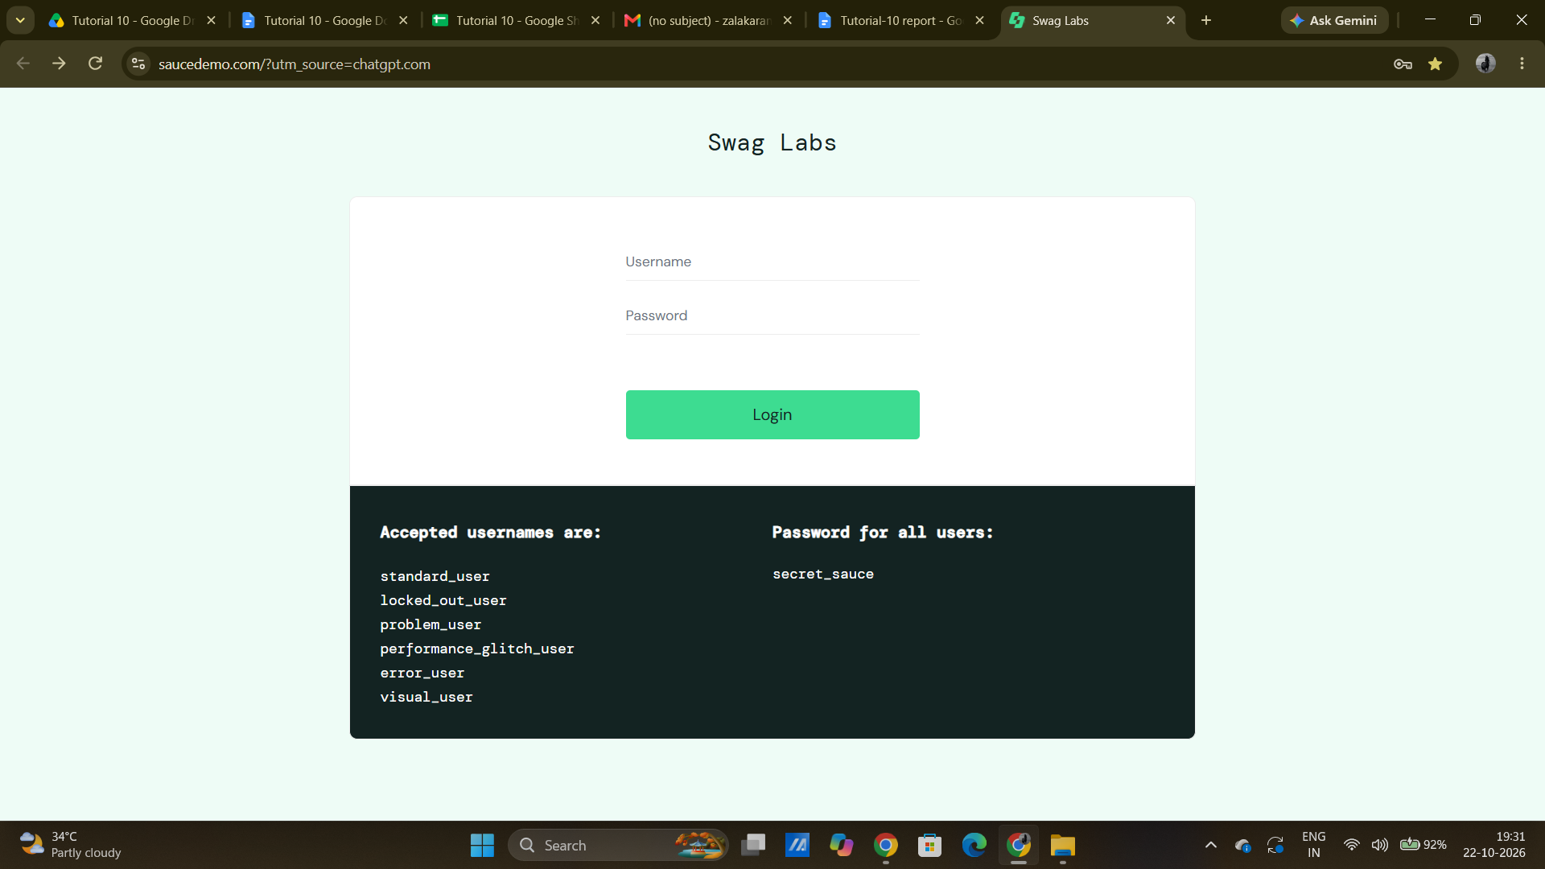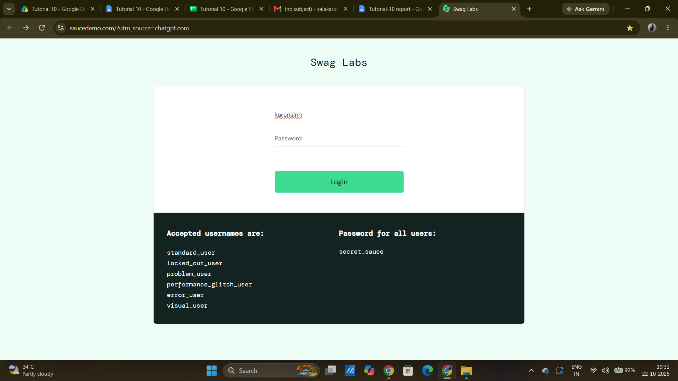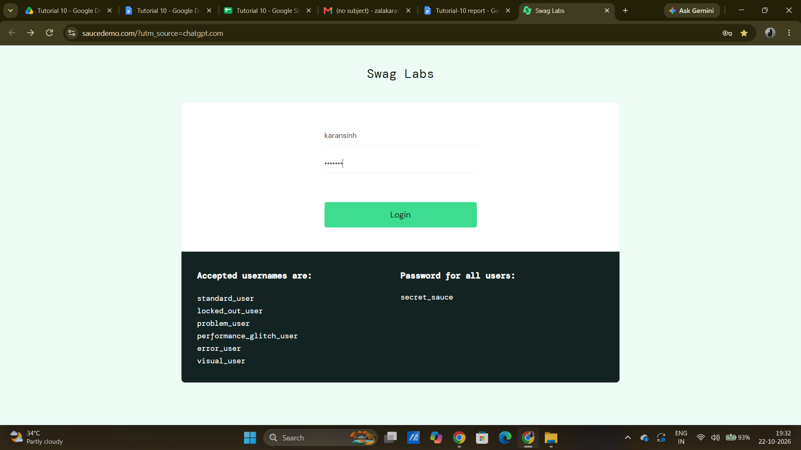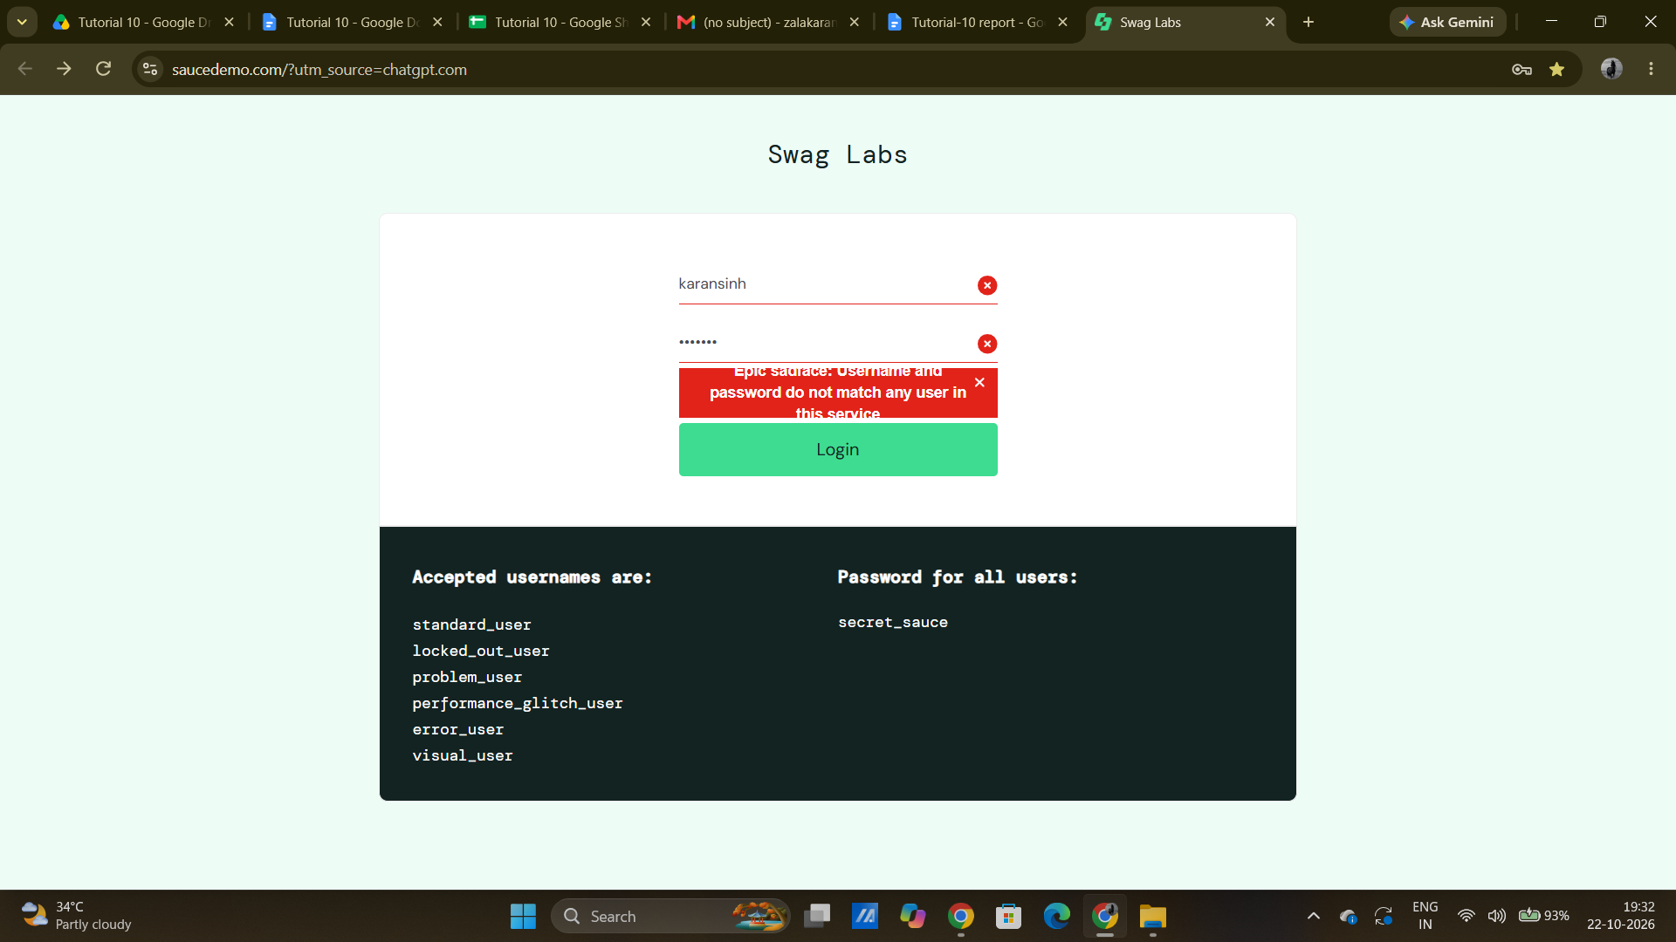Scenario ID: 3
Scenario: cart
Steps:
1.Add item to cart

Screenshots: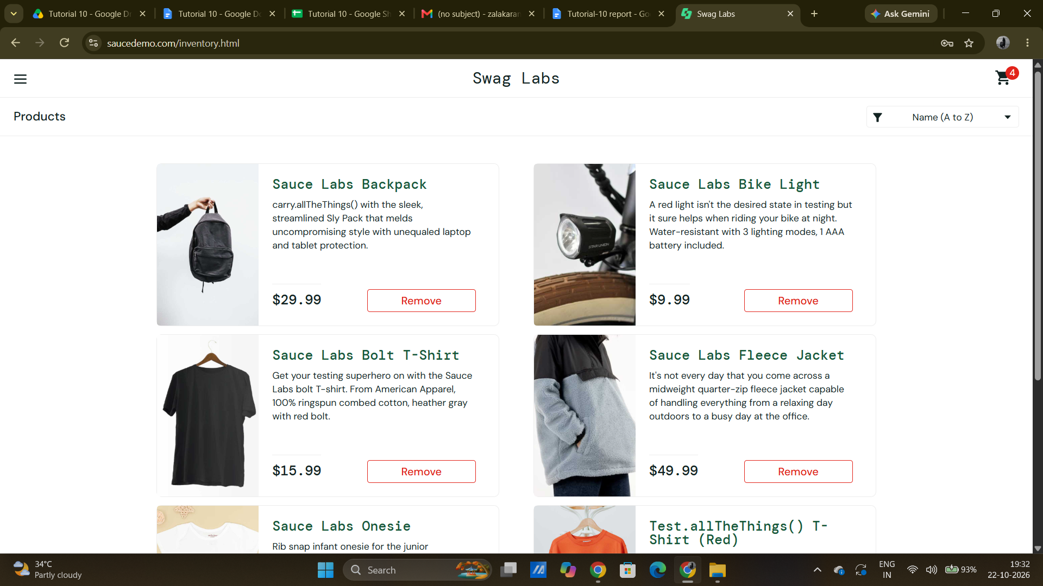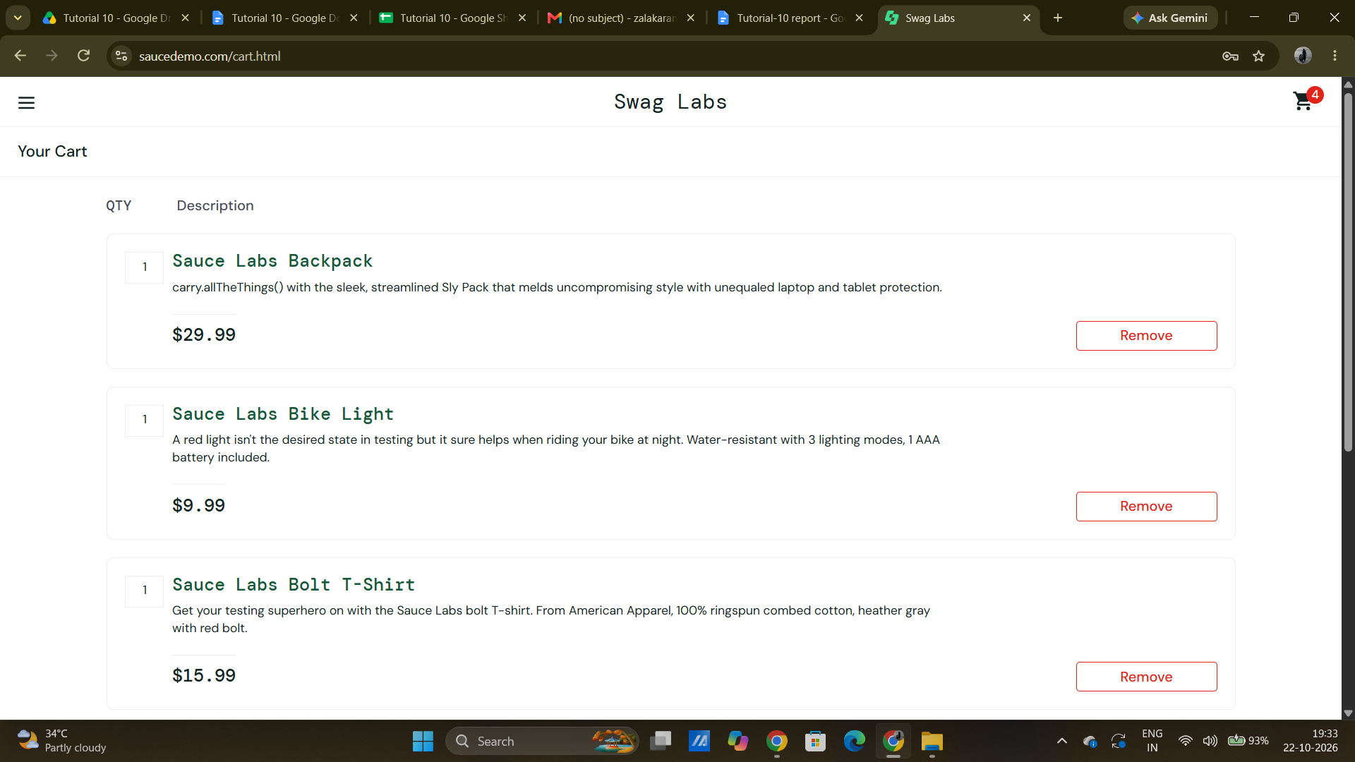Scenario ID: 4
Scenario: checkout Cart
Steps:
1. Tap on cart option and view items

Screenshots: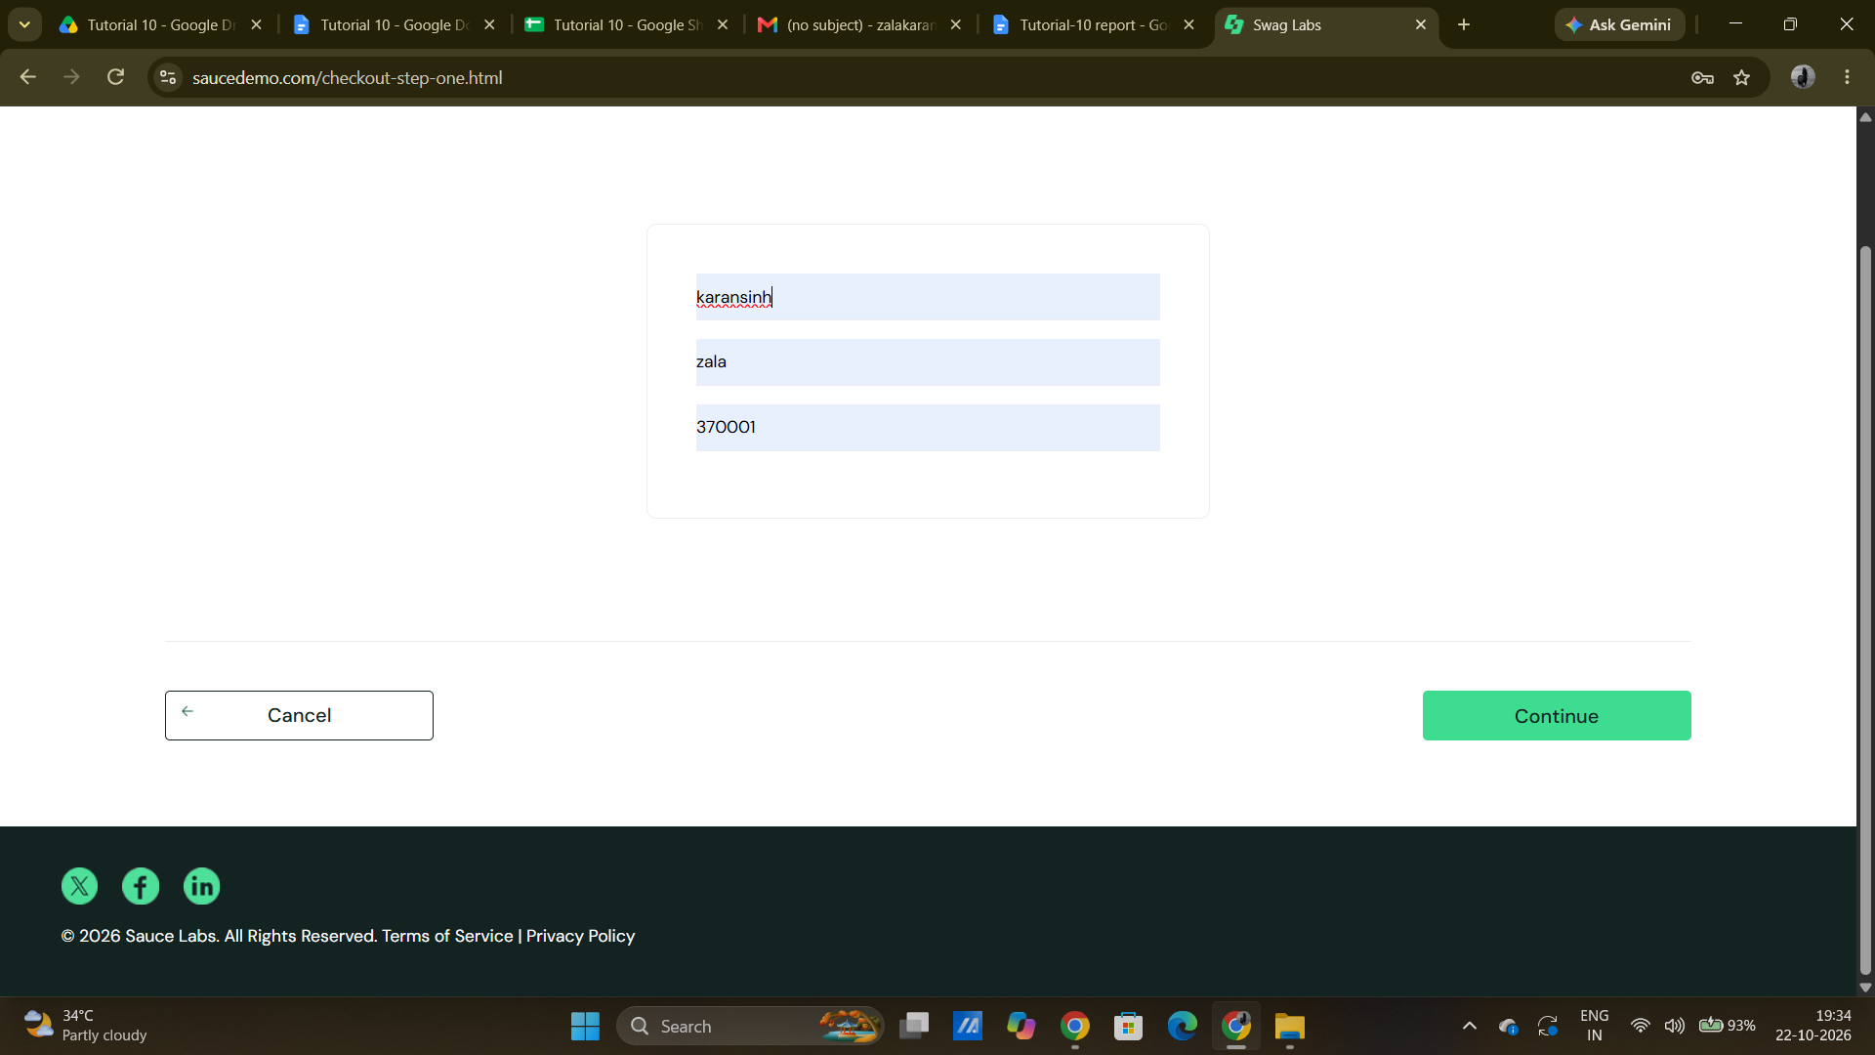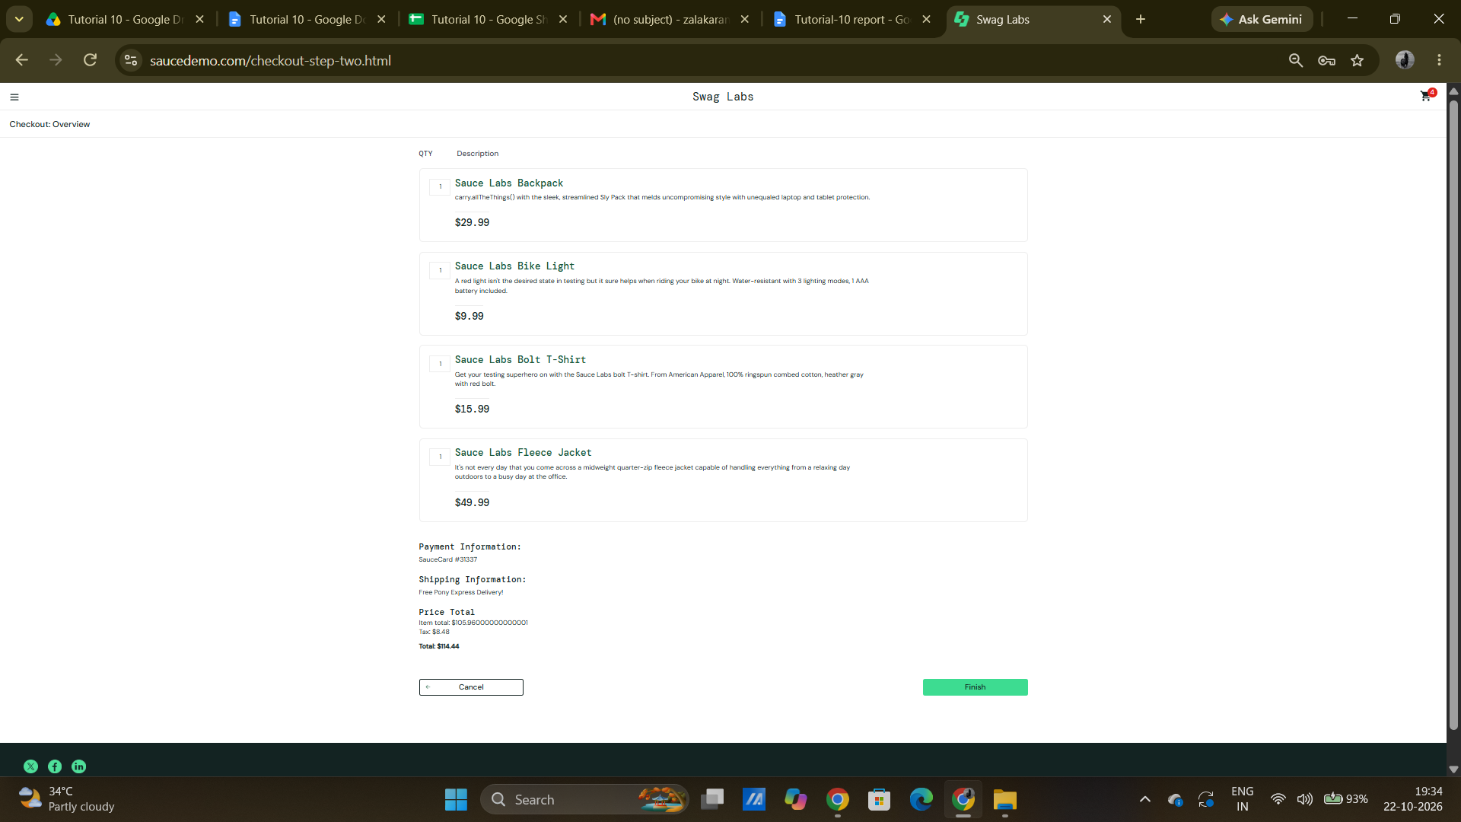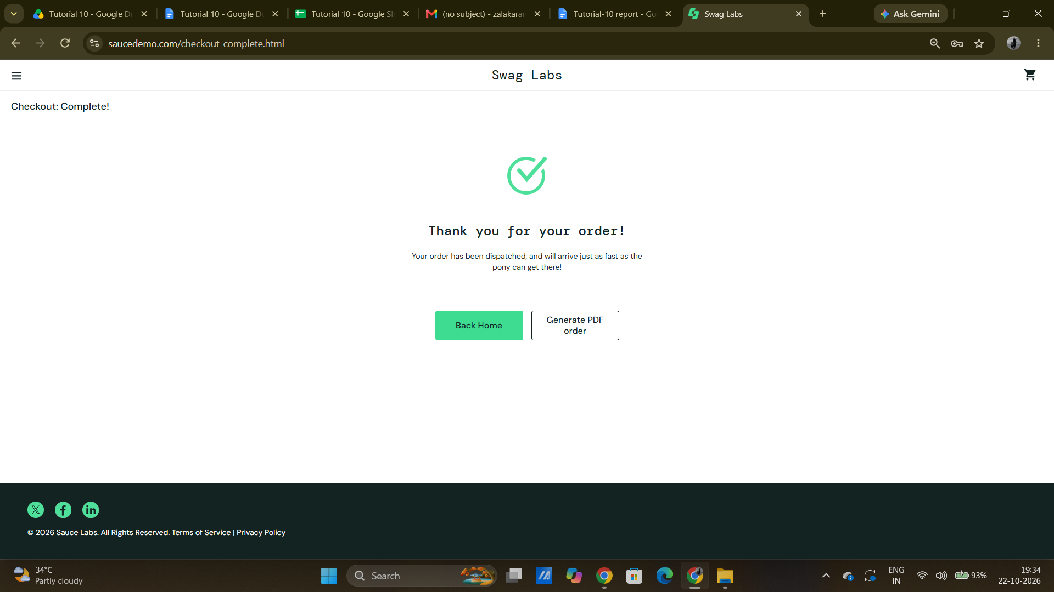
Scenario ID: 5
Scenario: logout
Steps:
1.Click ok logout

Screenshots:

